Q1. W.A.P. to demonstrate hide(),show(),toggle() Method.

* Code:

<!DOCTYPE html>

<head>

<title>Assignment-2</title>

<script src="./jquery-3.7.1.min.js">

$(document).ready(function () {

$("#btn1").click(function () {

$("img").hide();

});

$("#btn2").click(function () {

$("img").show();

});

$("#btn3").click(function () {

$("img").toggle();

});

});

</script>

</head>

<body>

<img src="./Tulips.jpg" height="200px" alt="Tulips">

<button id="btn1">Hide</button>

<button id="btn2">Show</button>

<button id="btn3">Toggle</button>

</body>

</html>

* Output:

hide()

Show()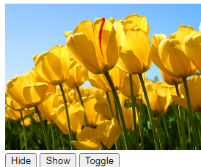

Q2. W.A.P.to demonstrate fadeIn(),fadeout(),fadeToggle(),

fadeTo() method:

* Code:

<!DOCTYPE html>

<head>

<title>Assignment-2</title>

<script src="./jquery-3.7.1.min.js">

$(document).ready(function () {

$("#btn1").click(function () {

$("img").fadeIn();

});

$("#btn2").click(function () {

$("img").fadeOut();

});

$("#btn3").click(function () {

$("img").fadeToggle();

});

$("#btn4").click(function () {

$("img").fadeTo(1000, 0.5);

});

});

</script>

</head>

<body>

<img src="./Tulips.jpg" height="200px" alt="Tulips">

<button id="btn1">Fade In</button>

<button id="btn2">Fade Out</button>

<button id="btn3">Fade Toggle</button>

<button id="btn4">Fade To</button>

</body>

</html>

* Output:

fadeOut: 

fadeIn:

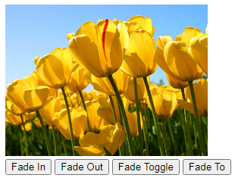

fadeToggle: 

fadeTo:

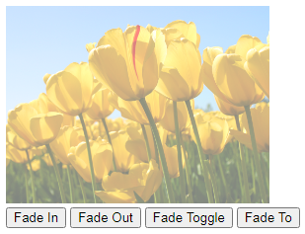

Q3. W.A.P. to demonstrate slideUp(),SlideDown(),slideToggle() Method.

* Code:

<!DOCTYPE html>

<head>

<title>Assignment-2</title>

<script src="./jquery-3.7.1.min.js">

$(document).ready(function () {

$("#btn1").click(function () {

$("img").slideUp();

});

$("#btn2").click(function () {

$("img").slideDown();

});

$("#btn3").click(function () {

$("img").slideToggle();

});

});

</script>

</head>

<body>

<img src="./Tulips.jpg" height="200px" alt="Tulips">

<button id="btn1">Slid Up</button>

<button id="btn2">Slide Down</button>

<button id="btn3">Slide Toggle</button>

</body>

</html>

* Output:

SlideUp:



slideDown:

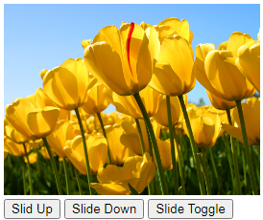

slideToggle:

